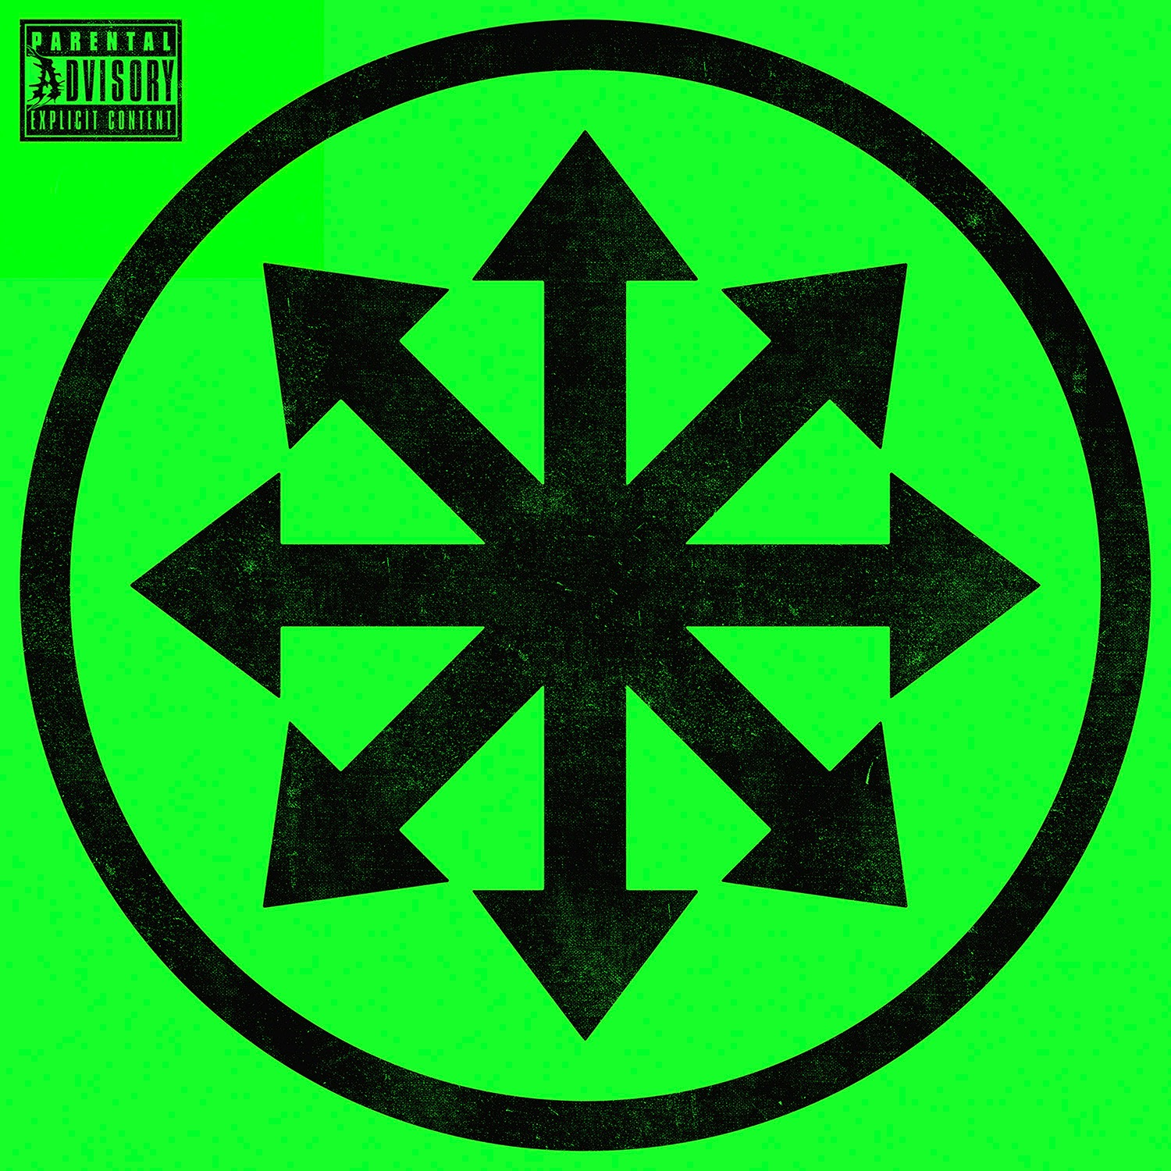
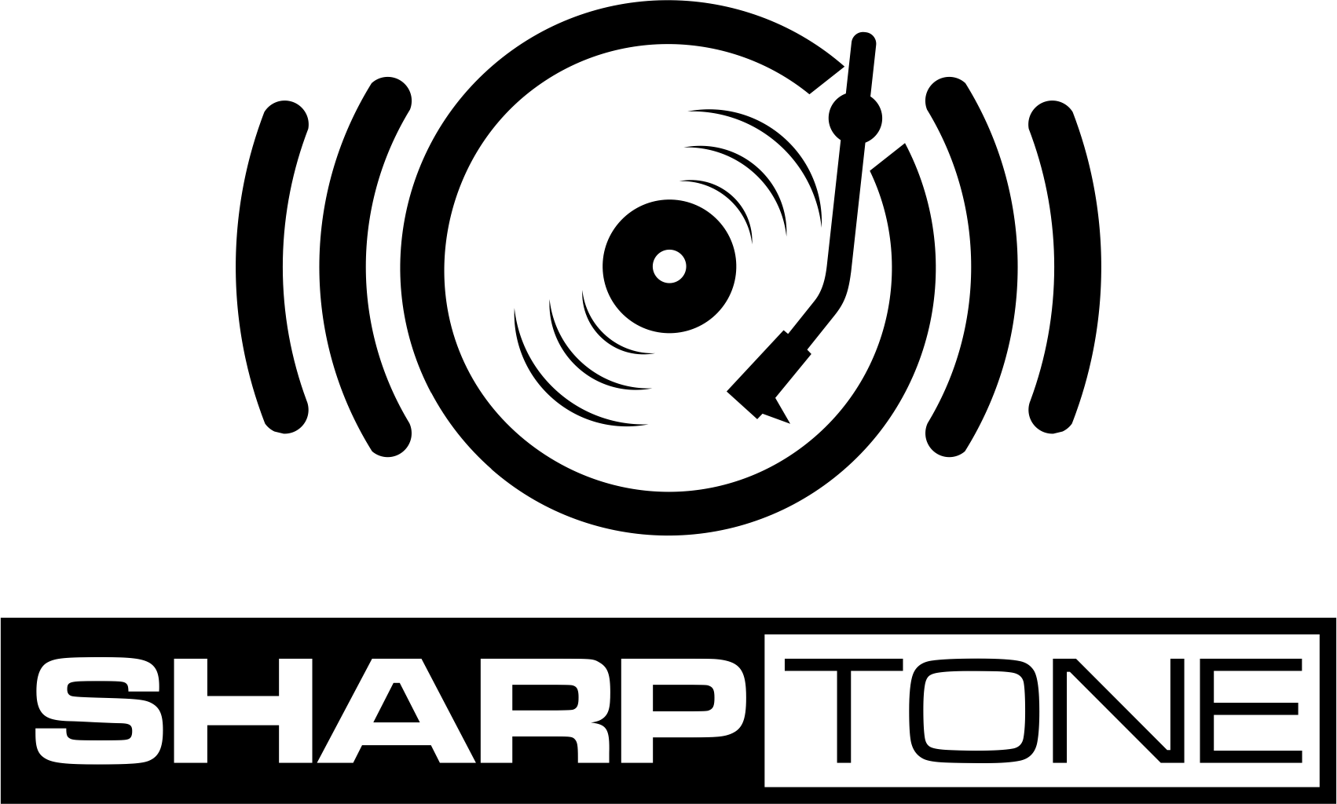

ATTILA
»CHAOS«
November 4, 2016

www.facebook.com/attilaGA
www.sharptonerecords.co/artist/attila

The fate of ATTILA was sealed the moment Chris “Fronz” Fronzak was handed a demo by his high-school pal Sean Heenan. It was a disc filled with the extreme sounds of underground metal, housed in the CD jewel case of an album by rapper/actor LUDACRIS.

It’s from these gritty essential ingredients, the “biscuits” of Southern-fried metal like PANTERA and the “gravy” of hip-hop like LIL JON, that ATTILA was born. Each of these seemingly disparate genres are united in aggressive force; in a shared authenticity; by a determination to keep it real, and with loud dedication to stay true to the game.

A cursory glance at something as simple as the titles of each of ATTILA’s seven albums reveals much of the band’s creative vision, each reading like a statement of intent. These are records called »Fallacy«, »Soundtrack to a Party«, »Rage«, »Outlawed«, and »About That Life«. As their singer’s devious Slim Shady styled alter-ego/persona Lord Fronzilla dishes out verbal beat down after beat down, with powerful bark and playful prose, his “zero f-bombs given” attitude is backed in kind by the bludgeoning rhythms dealt by guitarist Chris Linck, bassist Kalan Blehm and drummer/cofounder Heenan. To the legions of fans enraptured by the boisterous bravado of Fronz and his effortless charisma, ATTILA is the ultimate »Guilty Pleasure«, just as their 2014 album was named. ATTILA is beautiful »CHAOS«.

The first result of their partnership with SharpTone Records, the company formed by Nuclear Blast owner Markus Staiger and Shawn Keith, »CHAOS« arrives armed with many of the key elements of ATTILA’s signature sound, including steel-toed Southern stomp, shredding solos, and Fronz’s instantly recognizable voice. But what ’Ignite,’ ‚Bulletproof,‘ ‚All Hail Rock And Roll‘ and the rest of the eleven tracks on »CHAOS« collectively represent is ATTILA’s most finely honed, focused and dynamic offering yet. Simply put, »CHAOS« is the biggest album they’ve ever made.

ATTILA’s latest musical manifesto ranges from heavy moshpit invocations to metallic groove; from an EDM track (made in collaboration with rising EDM star OOKAY) to ready-made Active Rock radio hits, akin to LINKIN PARK or the recent work of fellow deathcore-kingpins-turned-transformative-anthem-makers BRING ME THE HORIZON. »CHAOS« is truly a form of organized CHAOS. ATTILA are their own ringmasters, setting their carnival ablaze.

“ATTILA has grown up with this album, but we're still ourselves, because it’s not boring dad rock or something,” the band’s colorful frontman observes. “It’s still offensive. It’s still edgy. It’s still in your face. We knew going into making this record that we’d be combining different ideas while still keeping our signature sound. Every song has purpose and it’s something you can feel when you’re listening to the entire album.”

Atlanta is a city that’s given the world the savage metalcore of NORMA JEAN and THE CHARIOT; the heady thinking-man’s metal of MASTODON; the soaring Active Rock of SEVENDUST, and the nü-metal/pop-core mash-up of ATTILA’s pals in the band Issues. Atlanta was rather famously the place where the SEX PISTOLS performed in America for the first time. Then there’s the massively influential Atlanta hip-hop and R&B scenes. Local production trio Organized Noize alone is responsible for huge hits by hometown heroes like TLC, LUDACRIS, GOODIE MOB and the badass ATLiens themselves, OUTKAST.

To move forward, ATTILA wisely looked backward to their roots. The band’s album making process could rightly be called “back to the future,” as they reexamined their original intentions and methodology to fully form their band’s future. Fronz remembers feeling uninspired by the monotone delivery of many extreme music vocalists and opted for more diversity from day one. On »CHAOS«, he ups the ante further, adding a new dimension with tuneful scream/singing in addition to his guttural growls and rapping.

The band spent more time writing and recording »CHAOS« than any other album. Which isn’t to say the record is overproduced. In fact, it’s far from it. ATTILA teamed up with Erik Ron, who has been in the studio with PANIC! AT THE DISCO, FOXY SHAZAM and, CROWN THE EMPIRE. But first and most importantly, »CHAOS« was born in the practice room.

“We sat down in a room together and asked, ‘What did we do when we wrote the first few albums that we don’t do anymore?’ We realized the thing we’d stopped doing was getting together and jamming in a basement,” Fronz recalls. “It’s so easy for bands to sit around a computer and create music. It’s too easy to forget to jam the songs in person, on real instruments. Everything about »CHAOS« is real, because we all met up in Georgia, right near the basement where we used to meet up when we were living off Taco Bell.”

Every member of the band was very involved in every phase of the album’s creation, from the earliest songwriting through the duration of the time in the studio. “It began with four dudes jamming out in a basement, rocking out in a basement, writing music that we love for the feel of it. There is a lot of feeling, a lot of realness on this album.”

Fitting, of course, that the sometimes controversial and always incredible champions of Warped Tour chose to name their boldest effort yet after the number one thing ATTILA will always conjure: »CHAOS«. After all, these are the guys who costarred on the hilariously tongue-in-cheek named Supervillains Tour, alongside Ronnie Radke’s FALLING IN REVERSE and METRO STATION, featuring pop culture firebrand TRACE CYRUS. Nothing ATTILA does is by accident and by far, »CHAOS« is their most confident and self-assured album yet.

Make no mistake, ATTILA is still absolutely nuts and completely in-your-face. »CHAOS« will introduce that craziness to a much bigger portion of the unsuspecting masses.

“Part of me wants to scream from a mountain top about how great this album is,” admits Fronz. “But I know that this record is going to get out there to people and they’ll know it for themselves. It's as heavy as ATTILA has always been, but it's even more digestible. We're not trying to hold back. We're not trying to limit ourselves. We want to be the biggest band in the world, but without ever sacrificing who we truly are.“

ATTILA:
Chris “Fronz” Fronzak – Vocals
Chris Linck – Guitar
Kalan Blehm – Bass
Sean Heenan – Drums

© SharpTone Records

